Multipurpose Real Property Complex –Algeria Zone 1 Residential Buildings
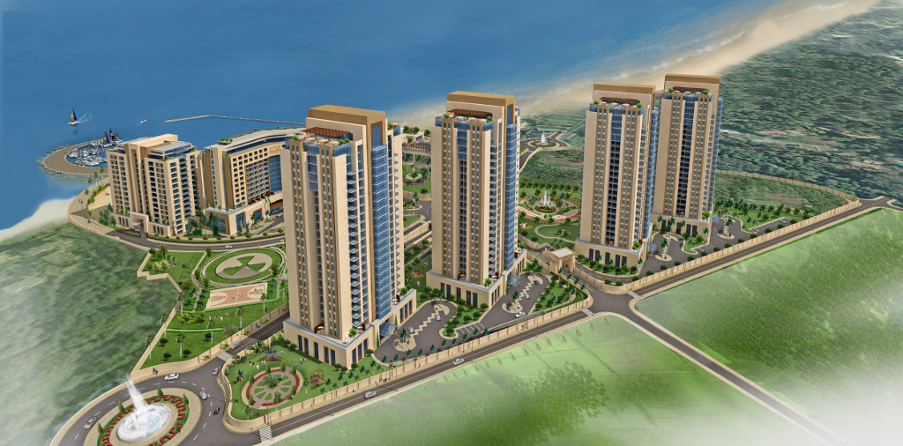
  - Baseline Schedule Narrative

Contents

- Project Brief
- Program Overview
- Key Dates/Milestones
- Work Breakdown Structure
- Calendars
- Activity Codes & ID
- Construction Sequence
- Project Baseline Schedule
- Critical Path
- Engineering Schedule
- Procurement Schedule
- Histograms
- Hill Comments Response
- Appendices
- Work Breakdown Structure
- Architectural Layouts.
- Project Baseline
- Critical Paths
- Engineering List of Shop Drawings
- Procurement Schedule
- Man-Hours Histogram
- CD Attachment

Project Brief

Project is located in the town of Staoueli, Wilaya of Algiers building four high rise residential buildings, each comprising of 3 basements + Ground + Mezzanine + 22 floors + saloon terrace and each high rise building comprising of 124 apartments with total built up area of the 4 buildings = 211,768 m2.

Program Overview

The purpose of this schedule is to review the base line schedule and incorporate comments sent by Hill reference 0001-CP01-PW-HI-DS-TRN-0037 for the submitted baseline schedule submission Rev 1 reference 0001-CP01-CN-DS-HI-TRN-0058.

The submitted schedule is presented via Primavera P6 Project Management. The total number of activities is now 19,202 activity incorporating all milestones and various stage/activities from Mobilization, Engineering, Procurement, Construction, Testing & Commissioning to Handing over. Program has been resource loaded with labour manhours & unit cost.

Key Dates/Milestones

The developed program is based on data date 1st of September 2012 and showing 3rd of March 2015 as the completion date of the project as per contract agreement. The below tables show the key dates of different project levels.

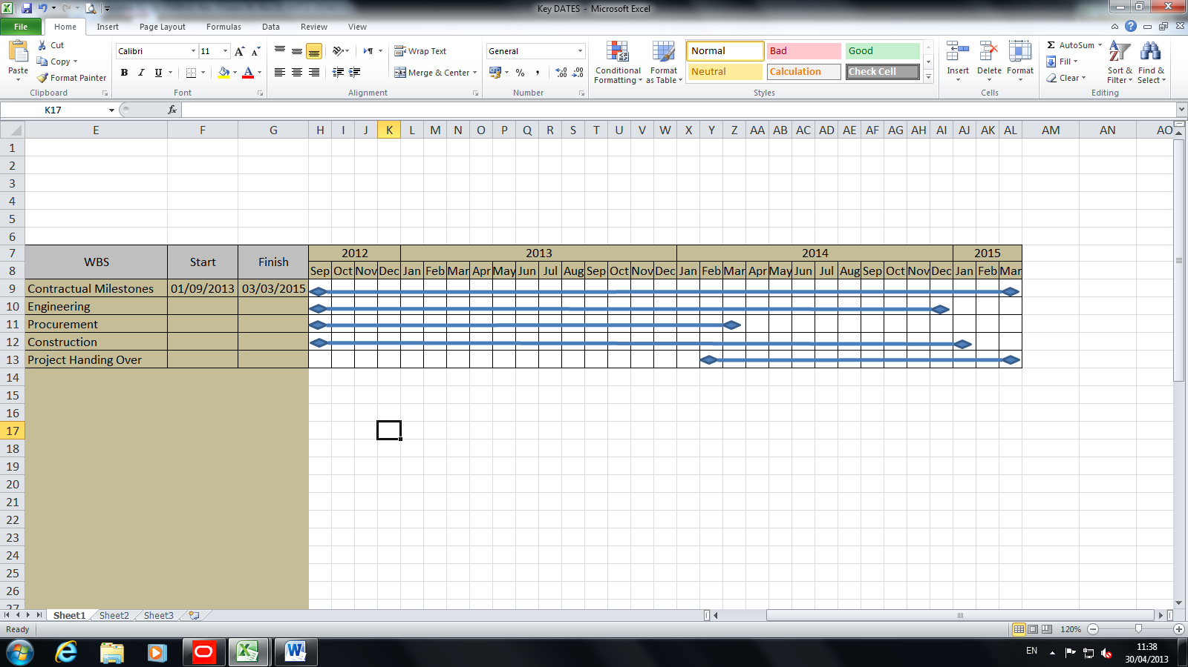

Work Breakdown Structure

The Work Breakdown Structure (WBS) is per definition the decomposition of a project activities into smaller components with several levels that help to organize and define the total work scope of the project . The Charts below show the main decomposition of each section of the project.
Moreover, the full Work Breakdown Structure is attached herewith in Appendix A.

Project Decomposition

Engineering WBS (Main Decomposition)

Procurement WBS (Main Decomposition)

Construction WBS (Main Decomposition)

Level 2
Construction

Structure
(Sub & Super Structure)
Level 3

Level 4
(Raft, Parking & Towers)
Sub Zones/Floor
Discipline
AREA

Towers
Floor

Towers 1 to 4
Level 5

Level 6
Basements, Floors GF TO Roof

Level 7
Structural, Architectural & MEP

Dry, Wet, Common Area etc…)
Level 8

Calendars

The calendar used in this baseline program comprises of the following; weekends (Friday only) 8 hours working day . Public and religious holidays have been added to the calendar. Certain activities have different calendars for example: concrete of rafts as it can only be poured on weekends due to the long duration of the pouring. Another calendar criteria used is a 7 day work week duration for some activities as curing and testing activities. Below is the public & religious holidays added to the main general calendar under the name of “Emiral - Algeria”.

Day | Description
Eid El Fitr | 2 Calendar Days
Eid Al Adha | 2 Calendar Days
Labour Day | 1st May
Independence Day | 5th July
Revolution Anniversary | 1st November
El Mawlid Annabawi | 12th Rabie Al Awal (Changable)
Awal Mouharam | 1st Mouharam (Changable)
Achoura | 10th Mouharam (Changable)

Activity Codes & ID

Activity codes & ID are assigned to the activities to help in monitor and control of the project they are as follows:

Activity ID

All activities have been assigned with a code in a simple way to help in finding any activity, methodology used is shown in the following activity as an example where the activity ID is highlighted in yellow:
E-T-T2-FN-GFML0040: Block Works
Activity Name | Activity Code | Description
Block Work | E | Emiral
 | T | Tower
 | T2 | Tower 2
 | FN | Finishing
 | GFML0040 | Ground floor, Main Lobby, Number

General Codes

No. | Activity Code
1 | Sub-zone
2 | Division -2
3 | Areas
4 | Trade -2
5 | Level -2
6 | Floor -2

Activity Code No.1: Sub Zone

Code Value | Description
Gen | General Area
T01 | Tower 1
T02 | Tower 2
T03 | Tower 3
T04 | Tower 4
MED | Mechanical Drawings
ELD | Electrical Drawings
BWD | Builder work Drawings
RCP | RCP Drawings
DR | Drainage
PL | Plumbing
FF | Fire Fighting
AC | HVAC – Air Side
Fuel | Fuel System (Generator)
PW | Power & Lighting
ELV | ELV Systems
EWMep | External Works – MEP
Msys | Mechanical Systems
Esys | Electrical Systems

Activity Code No.2:Division -2

Code Value | Description
Contr | Contractual Milestones
Const | Construction Works
Engg | Engineering Works
Proc | Procurement
Auth | Authority Approvals
TC | Testing & Commissioning
Snag | Snagging & Desnagging

Activity Code No.3:Areas

Code Value | Description
MLOBBY | Main Lobby
MULTI-H | Multifunction Hall
OTHER | Other Areas
BATH | Bathrooms, Kitchens & Laundry
SPA | SPA Area
TCOMM | Technical Common Area
Ramp | Ramp Area
UT & P | Under Tower & Podium Area
UT | Under Tower
P | Podium
DRY | Dry Area
WET | Wet Area
COMM | Common Area
PLANT | Plant Area
CLOSED | Closed Area
TERR | Terrace Area
ALL | All Areas
FLOOR | Floors
FAÇADE | Facades
POOLS | Swimming Pools
ELEV | Elevators & Esclators

Activity Code No.4:Trade-2

Code Value | Description
Gen | General
Struct | Structural Works
Finishi | Finishing Works
DR | Drainage
MEP | MEP Installations
WS | Water Supply System
FF | Fire Fighting System
AC | HVAC System
CHW | Chilled Water System
LT | Lighting System
PW | Power System
FA | Fire Alarm System
TL | Telephone system
TV | MATV System
VP | Video phone System
IA | Intrusion Alarm System
BMS | BMS
SO | Builder Work Slab Opening
WO | Builder Work MEP Core Wall Opening
RCP | RCP drawings

Activity Code No.5:Level -2

Code Value | Description
Gen | General
Parking | Parking
BToM | From Basement to Mezzanine
TYP | Typical Floors
Towers | Towers
T1 | Tower 1
T2 | Tower 2
T3 | Tower 3
T4 | Tower 4
Extern | External
ME | Mechanical
EL | Electrical
SNG T1 | Snagging & Desnagging Tower 1
SNGT2 | Snagging & Desnagging Tower 2
SNGT3 | Snagging & Desnagging Tower 3
SNGT4 | Snagging & Desnagging Tower 4

Construction Sequence

Structural Sequence

The Structural sequence which will drive other disciplines (Finishing & MEP) and consequently drive the whole project was implemented in the program after excessive amount of internal discussions with construction team, project management and the control team so that the sequence of works is built up according to what will be constructed on site and close monitoring would be applicable , the following layout shows the sequence of actual and agreed construction.
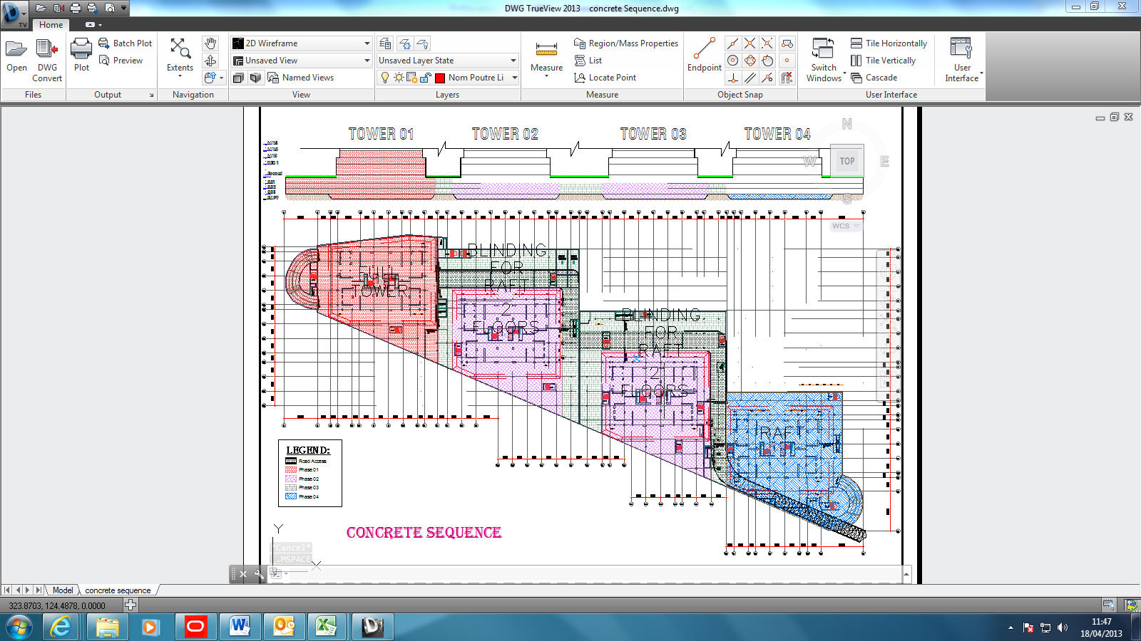

The Legend shows the sequence of work as tower 1 is completely independent and described as phase 1 while Tower 2 & 3 as phase 2, Podium of Tower 2 & 3 as phase 3 and Tower 4 as phase 4.
The Podium of Tower 2 & 3 will not start till 2 floors of Tower 1 & 2 are poured (Due to accessibility constraints on site) . Tower 4 Raft will not start till podium of Tower 2 blinding concrete raft is poured (To close access ramp on site) after that every Tower is independent and all towers are accessible.

Architectural & Mechanical Sequence

The following layouts shows how we divide floors for architectural & MEP works to have better monitoring on site we have concluded each tower into 6 main floors as the rest is identical to these floors Which are:
- Basement Floor
- Ground Floor
- Mezzanine Floor
- Technical floor
- Typical Floor
- Floor Saloon.
Attached as Appendix B

Project Baseline

Refer to the full schedule attached in Appendix C that shows 7 columns which are:
- Activity ID
- Activity Name
- Original Duration
- Start Date
- Finish Date
- Percentage Complete (Schedule percentage complete)
- Total Float

Any other column can be viewed on Primavera program itself (XER file is attached with the baseline submission CD Attachment).

Critical Path

The critical path is represented by the following diagram.

Detailed critical activities are shown in Appendix D.

Engineering List of Shop Drawings

Refer to shop drawing list attached as Appendix E.

Procurement Schedule

Main Material and subcontract packages key dates are incorporated in the main schedule. Detailed procurement schedule is attached in Appendix F. Procurement activities in this program show and limited to the following:
- Prepare & Submit material.
- Review & Approval of material.
- Issue purchase order.
- Manufacture/Shipping of material.
- Clearance & Delivery of material.

Histograms

The Schedule activities are loaded with labour manhours and cash flow unit costs . Appendix G shows histograms & cumulative data for early & late dates of man hours & cost.

Hill Comments

Hill comments on Rev. 1 reference 0001-CP01-PW-HI-DS-TRN-0037 are incorporated and summarized as per the following action table:
Comment No. | Status
1.1 | Base Line Narrative (Done)
2.1 | Appendix A (Done)
2.2 | Replied in point No. 5 (Done)
2.3 | Can’t decrease activities
2.4 | (Done)
2.5 | (Done)
2.6 | (Done)
2.7 | Structural & Engineering Shop drawings has been increased (Done)
3 | All constraints removed (Done)
4 | (Done)
5 | Has been noted and implemented on program (Done)

Appendices

- Work Breakdown Structure.
- Architectural Layouts.
- Project Baseline.
- Critical Paths.
- Engineering List of Shop Drawings.
- Procurement Schedule.
- Histograms.
- CD Attachment.

Appendix A (Work Break Down Structure)

Appendix B (Architectural Layouts)

Appendix C (Project Baseline)

Appendix D (Critical Path)

Appendix E (Engineering List of SD)

Appendix F (Procurement Schedule)

Appendix G (Histograms)

Appendix H (CD Attachment)

